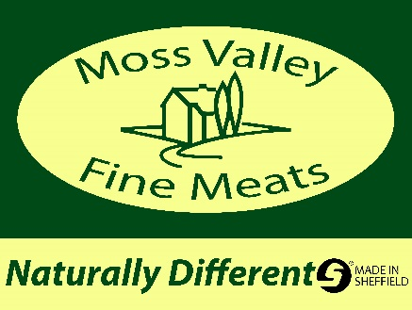
Hog Roast Prices
£50 deposit required on all DIY bookings
£200 deposit required on all served prices
£30 cleaning fee (if returned not up to standard)
Delivery included within 10 mile radius
DIY Prices
Hog 1 – Hog machine including gas £150
Hog 2 – Hog machine, gas & pig (to feed 70-90 people) £500
Hog 3 – Hog machine, gas & pig (to feed over 100 people) £550
Served Prices
Moss Valley will bring the full set up with our tent, tables and hog machine and do all the work for you. All served with soft white bap fresh from local bakery, stuffing & apple sauce (G/free options available) quality disposable cutlery, napkins & plates included.
Hog 4 – 70 - 90 people £950
Hog 5 – 100 - 120 people £1100
Roast Pork leg joints
Moss Valley will bring the full set up with our tent, tables and hog machine and do all the work for you. All served with soft white bap, stuffing, apple sauce & roast potatoes (G/free options available) quality disposable cutlery, napkins and plates included.
Our pork will cook on a cradle slowly and give the best crackling in the hog machine.
No less than 70 people
£12 pp
Extras (mainly for DIY packages)
Roast potatoes £2 pp
Hog prep on spike including cure £15
Cradle hire £30
Delivery over 10 miles 50p per mile
3 metre x 3 metre professional gazebo £20
4.5 metre x 3 metre professional gazebo £30
Tables and table cloths £10
Set up fee £30

